Android App

1. Android architecture:

* Summary Layer:

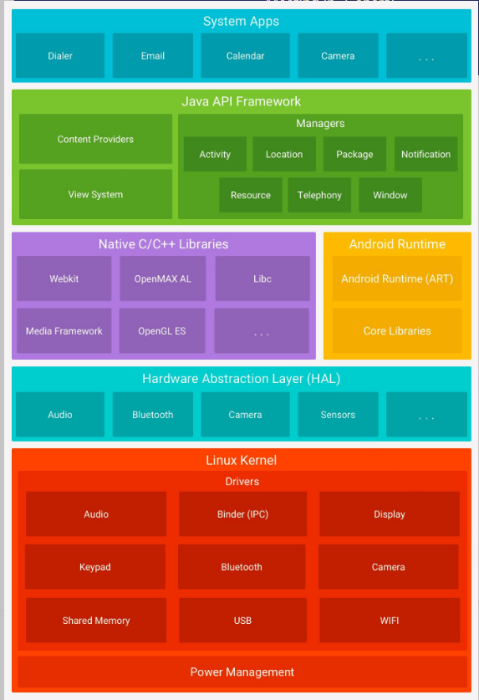

* Operating system of Android is Linux.

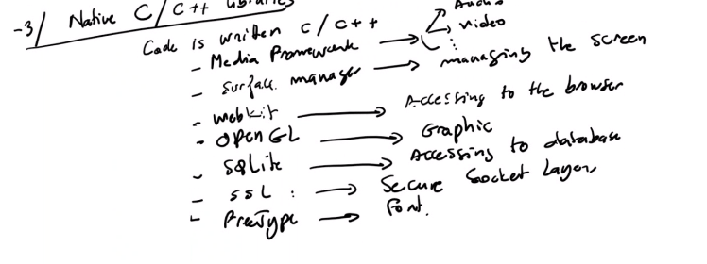

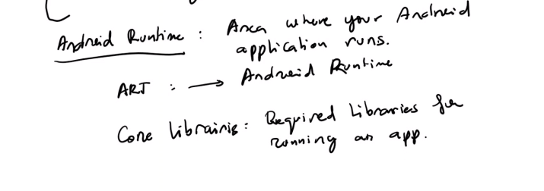



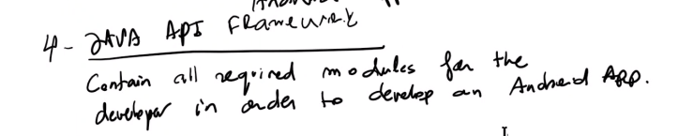

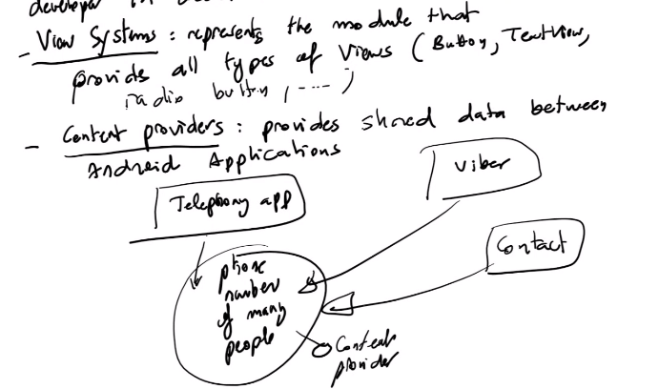

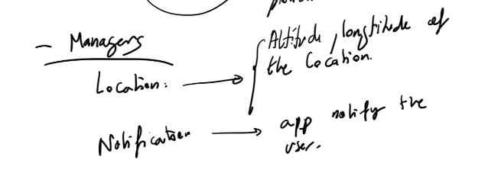

* First Layer is Linux: Generic operating system (important moduls for the operating system) => secure memory management, file I/O, network drivers,…
* Second Layer is Hardware Abstraction Layer (HAL): Prodvides standard interfaces that expose device hardware capabilities to the higher level
* Third Layer is Native C/C++ Libraries and Android Runtime:
  + Native C/C++ Libraries
    - Code is written in C/C++
    - In this layer we have:
      * Media Framework : Audio and video
      * Surface manage: managing the screen
      * Webkit: accessing to the browser
      * OpenGL ES: graphic
      * SQLite: Accessing to the database
      * SSL: Secure Socket Layer
      * Presstype: Font
  + Android Rumtime:
    - Area where your Android application runs
    - ART stands for Android Runtime
    - Core Libraries: required libraries for running an application (Shared libraries for an Android Application)
* Fourth Layer is Java API Framework
  + Java API Framework contains all required modules for the developer in order to develop an Android App
  + Java API Framework includes:
    - View systems: represents the module that provides all types of view (buttons, textview, radio button,…)
    - Content Providers: provides shared data between Android Applications. Example: Telephone app or Viber, or Zalo can access to the phone number data (so phone number data is content provider)

* + - Managers
* Fifth Layer is System applications:
  + Systems applications are the icons that appear in the screen of the device (such as Email, Calendar, Facebook, Phone, SMS,…)
  + There are two types of applications:
    - Default applications: Telephone, SMS, Camera, Calendar
    - Other applications (download by users): Facebook, Instagram,…

1. How android runs and installs an application:

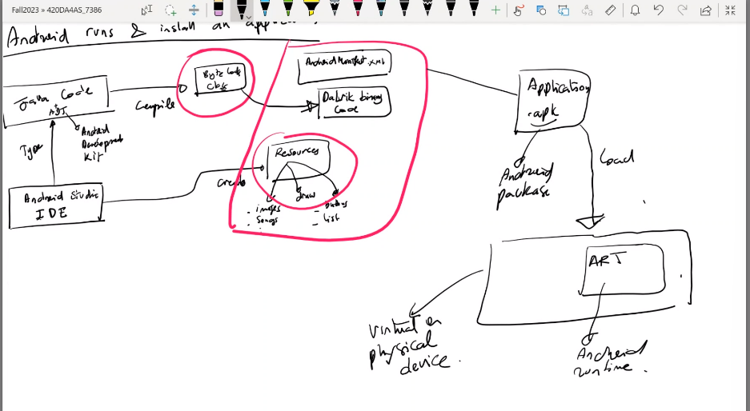

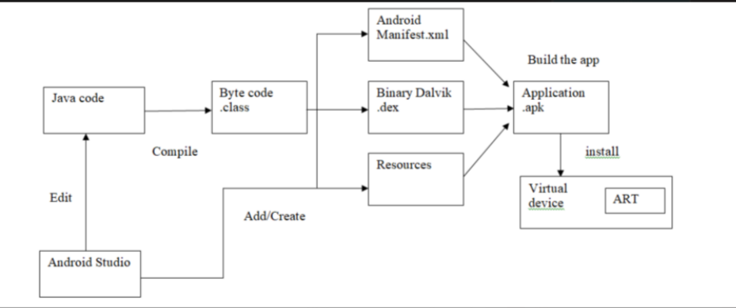

* ADT: Android Develoment Kit
* Byte Code Class
* Resources include images, songs, videos, buttons, list,…
* Android manifest.xml
* Davilk binary Code
* Application.apk: apk stands for android package
* ART: Android Runtime

1. Android Application Structure

* Create new Android Project
* Determine the main part of the project
* Manipulate the IDE

The Structure of Android App:

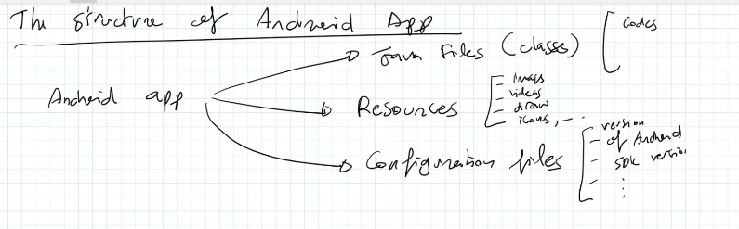

* Android App includes:
  + Java files ()
* To get UI in android studio, we have to open file activity_main.xml:

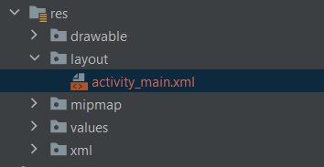

* Palette or we can call it Widget (it in file activity_main.xml ):

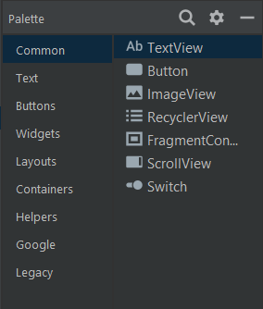

* The white one is called design view which is interface of App and the blue one is the blueprint which is about component

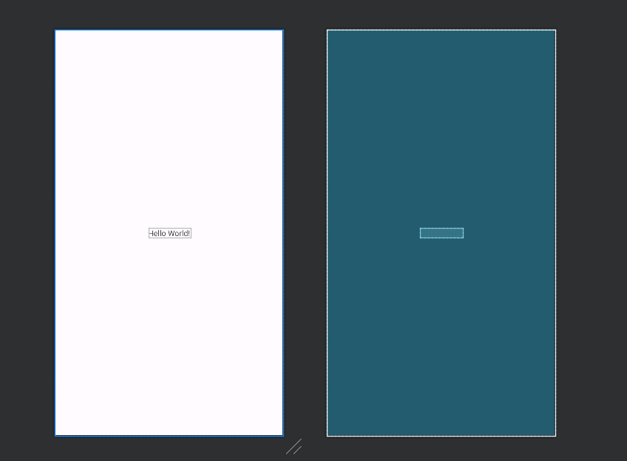

* Component Tree is corresponding to the white board above, if we select any components in componet tree, it will be automatically selected that componet in whiteboard above

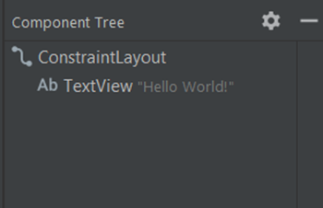

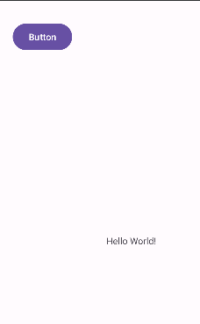

* To access the code of the design view (white board), click like image under:



(Click Code)

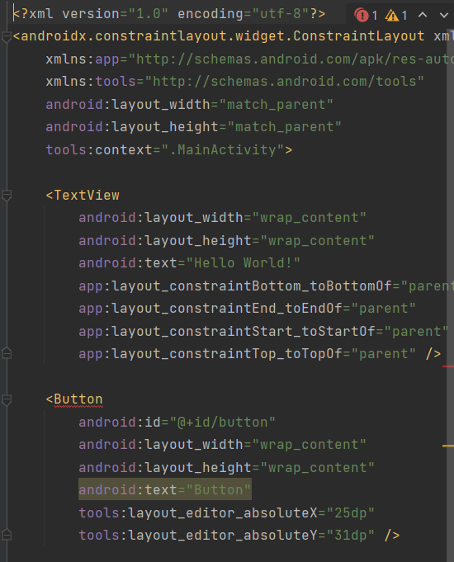

* To check any running device:

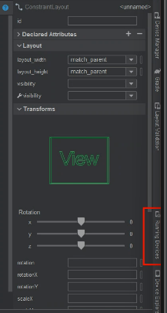

* To check how many device we have, click “Device manager”

